



Canadian Technical Report of

Fisheries and Aquatic Sciences XXXX

2021

Historical Summary of Sampling Station Relocations in the Annual southern Gulf of Saint Lawrence Snow Crab Survey

By

Tobie J. Surette

Fisheries and Oceans Canada

Science Branch

Crustaceans Section

343 Université Avenue

Moncton, NB

E1C 9B6

© Her Majesty the Queen in Right of Canada, 2021

Cat. No. Fs 97-6/XXXXE-PDF ISBN XXX-X-XXX-XXXXX-X ISSN 1488-5379

Correct citation for this publication:

Surette, T. J. 2021. Overview of the Snow Crab Survey Station Relocations in the southern Gulf of Saint Lawrence. Can. Tech. Rep. Fish. Aquat. Sci. XXXX: v + XX p.

**CONTENTS**

**ABSTRACT** iv

**RÉSUMÉ** iv

**CONTEXT** 1

**DESCRIPTION** 1

**ANALYSIS** 2

**CONCLUSION** 3

**REFERENCES** 4

**TABLES** 5

**FIGURES** 7

# **ABSTRACT**

Surette, T. J. 2021. Overview of the Snow Crab Survey Station Relocations in the southern Gulf of Saint Lawrence. Can. Tech. Rep. Fish. Aquat. Sci. XXXX: v + XX p.

An annual trawl survey forms the basis of stock assessment and management of the lucrative quota-based snow crab fishery in southern Gulf of Saint Lawrence. This survey has undergone a number of redesigns from its beginnings in 1988, with the most recent being in 2013. We quantify the number of sampling stations which were added over the history of the survey. From 2013 to 2020, we show that the practice of relocating sampling stations in response to serious trawl damage has shrunk the original set of 355 random stations of 2013, down to 186 stations in 2020, with the remaining 169 stations having been relocated one or more times over the period. A comparison of snow crab density trends between areas of the survey which containing relocations versus those which have remained fixed shows some signs of relative increase among the set of relocated samples, suggesting possible increase in survey catchability for certain groups of snow crab.

# **RÉSUMÉ**

Surette, T. J. 2021. Overview of the Snow Crab Survey Station Relocations in the southern Gulf of Saint Lawrence. Can. Tech. Rep. Fish. Aquat. Sci. XXXX: v + XX p.

# **CONTEXT**

The southern Gulf of Saint Lawrence snow crab annual survey has a 34-year history, from initial exploratory forays in 1987 and 1988 up to the present, providing fishery-independent data and biomass indices, the latter which are directly used to set annual quotas for this lucrative fishery. Over this period, the survey has undergone multiple expansions of its survey area, as well as changes in spatial sampling design, and the addition of new measurement devices and probes to improve data quality and catch standardization.

These changes have been highlighted as sources of possible sources of bias for annual abundance and biomass indices which form the basis of the management stock. A stock assessment review process in 2020 (Hébert et al, 2021) underlined a possible issue with the current practice of relocating survey stations when trawling difficulties (e.g. tear-ups) are encountered. While these station relocations are chosen randomly within their respective grids, which are the basic spatial units for this survey, the practice nevertheless would tend to displace stations to more trawlable sea bottoms as stations are repeatedly moved over time.

We present here a historical summary of survey station relocations to see to what extent survey stations were revisited or shifted to new locations from year to year. Other details on the sampling protocol and the historical development of this survey can be found in Moriyasu et al. 2008 and Hébert et al. 2021.

# **DESCRIPTION**

The spatial sampling design is based on randomly selected sampling stations within a regular grid overlaying the survey area. From 1988 to 2011, rectangular 10’x10’ grids were used and subsequently replaced square of square grids in 2012 onwards. Large subsets of sampling stations were fixed (i.e. resampled) from year to year, though new sampling stations were continually added through survey expansions, relocation of sampling stations from difficult to more favourable trawling locations, and in response to changes in spatial sampling design in 1991, 2006, and in 2012 and 2013 (Table 1).

Figure 1 shows a historical summary of the 2000 or so different sampling stations trawled in the regular snow crab surveys from 1988 to 2020. To generate this figure, the centre points for the entire set of regular snow crab survey tows (n = 9657) were compared and grouped together to the same sampling station if their center points were within 1.5 km of each other. This is our working definition of a station being “fixed” for the purposes of this document. Sampling stations were assigned numbers in their chronological order of appearance in the surveys.

From an initial set of locations in 1988, stations were added or redistributed over most years of the survey. In particular, new stations were rapidly added in the early part of the survey, which had its greatest areal expansion from 1988 to 1993. Only a partial survey was conducted in 1996 due to funding lack of funding. The period from 1994 to 2005 saw progressively smaller proportions of stations being added or re-located, in part due to technological improvements in geolocation plus a general tendency to relocate stations from difficult trawling areas to other areas within its sampling grid more suitable to trawling.

Following the survey sampling redesign in 2006, which saw a large redistribution of stations with a more uniform spatial distribution within the survey area, the set of sampling stations remained constant from 2006 to 2011, indicating a high degree of fidelity to the original set of survey stations, rather than relocating to alternate sampling stations.

Following the sampling design change in 2012, a completely new set of 325 survey stations were generated in 2012 and again for 355 stations in 2013. Sampling at new set of random stations led to relatively high rates of trawl damage and tow rejections for 2012 and 2013, relative to other years.Figure 2 shows the proportion of failed tows for 2007 to 2019. In particular ~17% and ~20% of attempted tows failed on the first attempt for 2012 and 2013, respectively. Given that the spatial sampling density over the survey area is fairly uniform, these proportions are also good estimates of the proportion of the current survey area which is trawlable on the first attempt. Figure 3 shows the specific locations where major trawl damage occurs in the survey, indicating that problematic areas are all along the north shore of Prince Edward Island, immediately West of Shediac Valley, and along the shallower edge of the Laurentian Channel. Figure 4 shows the total number of times survey stations have been moved within each survey grid from 2013 to 2019.

Tow rejection rates in 2006 to 2011 were much lower, at 9.5% to 11.7%, than those of 2012 and 2013. Thus the survey protocol from 2013 onward reverted to the earlier practice (before 2006) of relocating sampling stations to alternate locations when serious trawl damage occurred.

We selected the most recent survey design implementation of the survey, the series from 2013 to 2020, which had a fixed survey area and a fixed sampling scheme of 355 survey grids. By design, each grid contains a single sampling stations. In 2013, a random set of survey stations within each grid was generated. Though many of this original set of stations have remained fixed up to 2020, many have been relocated through the process of moving to alternate random stations when serious trawl damage occurred. For each survey grid (n = 355), we tabulated the number of times a survey station had been relocated for each year over time.

Table 2 shows a detailed breakdown of the number of survey grids, out of a total 355, which have undergone a specified number of sampling station relocations, between the 2013 and 2020 surveys. In particular, 67 stations from the original set of 355 random stations in were moved to alternates in 2013. Progressively more and more grids contained relocated stations, though the number of original stations being moved has decreased to about 11 per annum in the past 4 years. In 2020, only 186 from the original 2013 stations remained fixed, with 80 of the remaining stations moving once, 33 moving twice, 29 moving three times, and 27 moving four or more times.

# **ANALYSIS**

We sought to see whether the gradual displacement of trawl stations in certain areas to more trawlable bottom led to relative increases in snow crab abundance among the set of grids whose stations had been displaced over the period from 2013 to 2020.

To perform the analysis, we separated the set of 355 survey grids used in the 2013 to 2020 survey into two groups: those whose stations had remained fixed over the period, and those whose stations had been relocated one or more times in 2020. Removed from the analyses were the 69 grids which already contained an alternate station in 2013. Average annual densities were calculated for each group, and the ratio between the  relocated versus fixed set of grids was calculated. Four variables were selected for analysis: male and female instar VIII, mature females and commercial male recruits.

For male and female instar VIII, the ratio (moved/fixed) gradually increased remained relatively stable at ~50-60% from 2013 to 2015, with the ratio increasing for males in 2016 and again in 2017, and increasing in 2017 for females. The ratio then increased to very high levels above parity in 2018 and 2020 for both sexes, with a lower level in 2019 which was comparable to the 2017 levels of ~70-80%. For commercial recruits, the increase was more gradual, shifting from a ratio of ~50% to ~80% for 2017-2020. In contrast, the ratio for mature females was more stable, remaining between 50% and 65%, with no overall trend over the period.

The shifts observed for instar VIII and commercial recruits described above lends some support to the hypothesis that survey sampling bias may be increasing in conjunction with the increasing proportion of survey stations on trawlable bottoms. However, mature females do not show a similar shift. Scale differences in some natural processes between the two survey grid sets, such as recruitment, migration, may also be driving the observed trends in the ratios. In addition, the spatial distribution of grids with fixed stations is not random (Figures 3 & 4), reflecting areas of known trawlability, thus may be more subject to local effects.

# **CONCLUSION**

Almost half of survey stations have been moved at least once since 2013. Although the relocated station are chosen randomly within their respective grids, stations over time will naturally gravitate towards locales with lower probability of trawl damage. Thus, as stations locations settle onto more trawlable bottom, the probability of trawl damage will tend to decrease over time, as was observed over the period from 2013 to 2020. A similar decrease is observed for the period preceding the 2006 survey.

Different types of sea bottom reflect different habitats and likely contain different crab densities and possibly trawl catchability. Investigations on change in ratios between fixed and moved stations suggested some evidence of increasing catchability for instar VIII and commercial recruits, but remain inconclusive due to a contrasting trend for mature females and the known presence of confounding natural processes.

Though only and indirect means of inference, the comparison of density trends between grids whose stations have moved over the period from 2013-2020 versus those who have remained fixed shows an increasing trends for instar VIII recruits as well as commercial crab. However, mature females remained stable.

To monitor the impact of survey station relocations over time on abundance and biomass estimates, it is recommended that a representative subset of the original 2013 set of random survey stations be chosen to remain fixed in subsequent surveys, while the remaining stations may be relocated as per the current protocol. This protocol change would allow for monitoring of drift between the two portions of the data as well as correcting catches if a problem is detected.

True fixed station sampling was used for this survey from 2006 to 2011, which maintained its entire set of designated sampling stations throughout, with a tow rejection rate of 10.8% overall. However, though this rejection rate may be deemed acceptable, we note that more than half of these survey stations were retained from the set used in 2005, which presumably had undergone the same station relocation process mentioned above.

Given that the tow rejection rate for 2013 was 20.7% and that of 2020 was 9.7%, we estimate that holding 50% of sampling stations as fixed will yield a rejection rate of ~15%. Smaller numbers of fixed stations will lower the rejection rate, but will lower the statistical power of the fixed stations as a control measure.

# **REFERENCES**

Hébert, M., Surette T., Landry, J.-F., and Moriyasu, M. 2021. [The 2020 assessment of snow crab, *Chionoecetes opilio*, stocks in the southern Gulf of St. Lawrence (Areas 12, 19, E and F).](http://www.dfo-mpo.gc.ca/csas-sccs/Publications/ResDocs-DocRech/2011/2011_082-eng.html) DFO Can. Sci. Advis. Sec. Res. Doc. 2021/0XX.

Moriyasu, M., Wade, E., Hébert, M. and Biron, M. 2008. Review of the survey and analytical protocols used for estimating abundance indices of southern Gulf of St. Lawrence snow crab from 1988 to 2006. DFO Can. Sci. Advis. Sec. Res. Doc. 2008/069.

# **TABLES**

Table 1. Survey vessel and sampling summary. Shaded areas represents blocks of similar survey designs from 2006 onwards.

|  |  |  |  |  |  |  |
| --- | --- | --- | --- | --- | --- | --- |
| **Year** | **Vessel** | **Horsepower** | **Survey grid** | **Stations** | **Sampling** | **Survey area(km2)** |
| 1988 | Emy Serge D. | 375 | 10'x10' | 152 |  | 29336 |
| 1989 | Emy Serge D. | 375 | 10'x10' | 155 |  | 29345 |
| 1990 | Emy Serge D. | 375 | 10'x10' | 162 |  | 29250 |
| 1991 | Emy Serge D. | 375 | 10'x10' | 177 | new stations | 29254 |
| 1992 | Emy Serge D. | 375 | 10'x10' | 233 |  | 29254 |
| 1993 | Emy Serge D. | 375 | 10'x10' | 208 |  | 29254 |
| 1994 | Emy Serge D. | 375 | 10'x10' | 259 |  | 29254 |
| 1995 | Emy Serge D. | 375 | 10'x10' | 261 |  | 29254 |
| 1996 | Emy Serge D. | 375 | 10'x10' | 72 | partial | 29254 |
| 1997 | Emy Serge D. | 375 | 10'x10' | 259 |  | 29254 |
| 1998 | Emy Serge D. | 375 | 10'x10' | 261 |  | 31696 |
| 1999 | Den C. Martin | 402 | 10'x10' | 277 |  | 35748 |
| 2000 | Den C. Martin | 402 | 10'x10' | 280 |  | 35748 |
| 2001 | Den C. Martin | 402 | 10'x10' | 292 |  | 35748 |
| 2002 | Den C. Martin | 402 | 10'x10' | 319 |  | 35748 |
| 2003 | Marco-Michel | 660 | 10'x10' | 317 |  | 37518 |
| 2004 | Marco-Michel | 660 | 10'x10' | 347 |  | 37518 |
| 2005 | Marco-Michel | 660 | 10'x10' | 355 |  | 37518 |
| 2006 | Marco-Michel | 660 | 10'x10' | 354 | new design | 44302 |
| 2007 | Marco-Michel | 660 | 10'x10' | 355 |  | 44302 |
| 2008 | Marco-Michel | 660 | 10'x10' | 355 |  | 44302 |
| 2009 | Marco-Michel | 660 | 10'x10' | 355 |  | 44302 |
| 2010 | Marco-Michel | 660 | 10'x10' | 354 |  | 44302 |
| 2011 | Marco-Michel | 660 | 10'x10' | 353 |  | 44302 |
| 2012 | Marco-Michel | 660 | 13.4 x 13.4 km | 321 | new design | 57840 |
| 2013 | Jean-Mathieu | 720 | 12.6 x 12.6 km | 352 | new stations | 57840 |
| 2014 | Jean-Mathieu | 720 | 12.6 x 12.6 km | 353 |  | 57840 |
| 2015 | Jean-Mathieu | 720 | 12.6 x 12.6 km | 353 |  | 57840 |
| 2016 | Jean-Mathieu | 720 | 12.6 x 12.6 km | 354 |  | 57840 |
| 2017 | Jean-Mathieu | 720 | 12.6 x 12.6 km | 353 |  | 57840 |
| 2018 | Jean-Mathieu | 720 | 12.6 x 12.6 km | 354 |  | 57840 |
| 2019 | Avalon Voyager II | 850 | 12.6 x 12.6 km | 352 |  | 57842.8 |
| 2020 | Avalon Voyager II | 850 | 12.6 x 12.6 km | 353 |  | 57842.8 |

Table 2. Frequency table showing the number of survey grids having undergone a specified number of survey stations relocations since the survey redesign of 2013.

|  |  |  |  |  |  |
| --- | --- | --- | --- | --- | --- |
| **Year** | **0** | **1** | **2** | **3** | **4+** |
| 2013 | 288 | 57 | 9 | 1 | 0 |
| 2014 | 261 | 75 | 13 | 6 | 0 |
| 2015 | 237 | 79 | 25 | 12 | 2 |
| 2016 | 226 | 77 | 28 | 16 | 8 |
| 2017 | 217 | 76 | 26 | 25 | 11 |
| 2018 | 206 | 76 | 30 | 29 | 14 |
| 2019 | 195 | 78 | 28 | 28 | 26 |
| 2020 | 186 | 80 | 33 | 29 | 27 |

# **FIGURES**

**Macintosh HD:Users:crustacean:Desktop:Stock-Assessment-2020:results:figures:english:survey:Survey Station History.pdf**

Figure 1. Historical cumulative summary of sampling stations added during the annual southern Gulf of Saint Lawrence snow crab survey. Shaded lines indicate that a station was successfully sampled for a particular year. The y-axis shows the order of appearance of sampling stations, with older sampling stations found near the bottom and the most recent stations near the top. Annotations show major changes in survey sampling design.

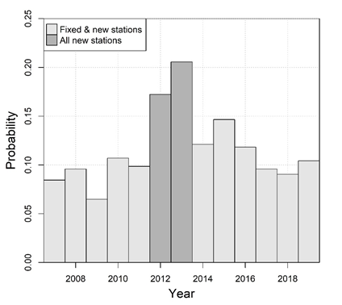

Figure 2. Proportion of tows rejected on the first attempt during the 2007 to 2019 snow crab surveys.

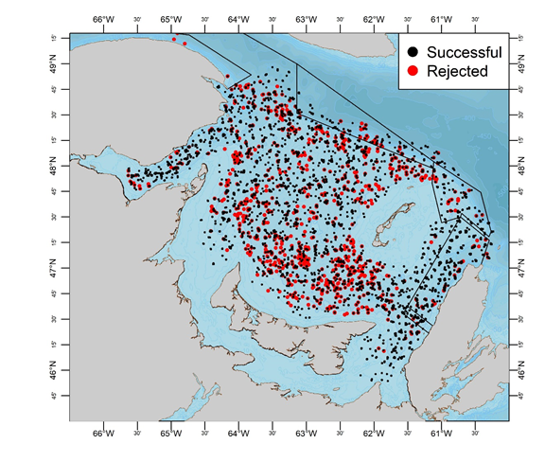

Figure 3. Locations of successful (black) and rejected (red) tows in the 2000 to 2019 snow crab surveys.

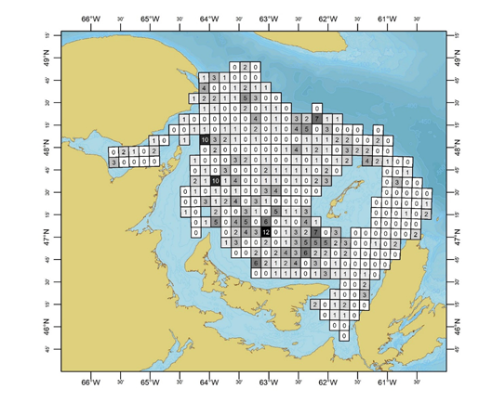

Figure 4. Map of survey sampling grids making up the current survey design, along with the total number of sampling station relocations which have occurred within them over survey years 2013-2019.

|  |  |
| --- | --- |
| **C:\Users\allainrn\AppData\Local\Microsoft\Windows\INetCache\Content.MSO\4B32039B.tmp** | **C:\Users\allainrn\AppData\Local\Microsoft\Windows\INetCache\Content.MSO\54517B61.tmp** |
| **C:\Users\allainrn\AppData\Local\Microsoft\Windows\INetCache\Content.MSO\A672B517.tmp** | **C:\Users\allainrn\AppData\Local\Microsoft\Windows\INetCache\Content.MSO\C8EF363D.tmp** |
| Figure 5. Ratio between densities of survey grids which contain survey stations which have moved over 2013 to 2020, over those whose stations have remained fixed, for four groups of snow crab: male instar VIII males (top left), females instar VIII (top right), mature females (bottom left) and commercial males (bottom right). | |